**MODULE:-5**

**1)Table: STUDENT & EXAM**

**STUDENT:-**

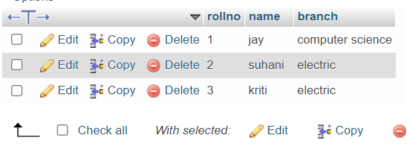

**CREATE**:-

CREATE TABLE student(rollno int(5) NOT null AUTO_INCREMENT PRIMARY KEY,name varchar(50),branch varchar(30));

**INSERT** :-

INSERT INTO student(name,branch)VALUES('jay','computer science'),('suhani','electric'),('kriti','electric');

**EXAM:-**

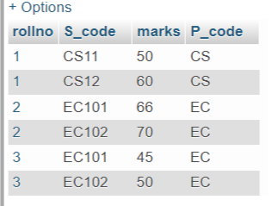

CREATE TABLE exam(rollno int(10) NOT null,S_code varchar(50),marks int(100),P_code varchar(50),FOREIGN KEY(rollno) REFERENCES student(rollno));

INSERT INTO `exam` (`rollno`, `S_code`, `marks`, `P_code`) VALUES ('1', 'CS11', '50', 'CS');

INSERT INTO `exam` (`rollno`, `S_code`, `marks`, `P_code`) VALUES ('1', 'CS12', '60', 'CS');

INSERT INTO `exam` (`rollno`, `S_code`, `marks`, `P_code`) VALUES ('2', 'EC101', '66', 'EC');

INSERT INTO `exam` (`rollno`, `S_code`, `marks`, `P_code`) VALUES ('2', 'EC102', '70', 'EC');

INSERT INTO `exam` (`rollno`, `S_code`, `marks`, `P_code`) VALUES ('3', 'EC101', '45', 'EC');

INSERT INTO `exam` (`rollno`, `S_code`, `marks`, `P_code`) VALUES ('3', 'EC102', '50', 'EC');

2**) TABLE:-2(TASK2)**

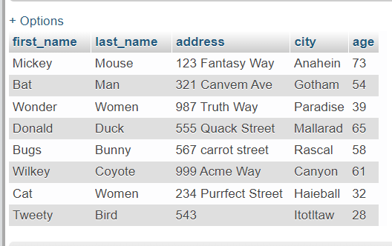

**CREATE**:-

CREATE TABLE task2(first_name varchar(25),last_name varchar(25),address varchar(30),city varchar(30),age int(100));

**INSRERT**:

INSERT INTO `task2` (`first_name`, `last_name`, `address`, `city`, `age`) VALUES ('Mickey', 'Mouse', '123 Fantasy Way', 'Anahein', '73'), ('Bat ', 'Man', '321 Canvem Ave', 'Gotham', '54');

INSERT INTO `task2` (`first_name`, `last_name`, `address`, `city`, `age`) VALUES ('Wonder', 'Women', '987 Truth Way', 'Paradise', '39'), ('Donald', 'Duck', '555 Quack Street ', 'Mallarad', '65');

INSERT INTO `task2` (`first_name`, `last_name`, `address`, `city`, `age`) VALUES ('Bugs', 'Bunny', '567 carrot street', 'Rascal', '58'), ('Wilkey', 'Coyote', '999 Acme Way', 'Canyon', '61');

INSERT INTO `task2` (`first_name`, `last_name`, `address`, `city`, `age`) VALUES ('Cat', 'Women', '234 Purrfect Street ', 'Haieball', '32'), ('Tweety', 'Bird', '543', 'Itotltaw', '28');

**3)TABLE: EMPLOYEEE & INCENTIVE**

**EMPLOYEE:-**

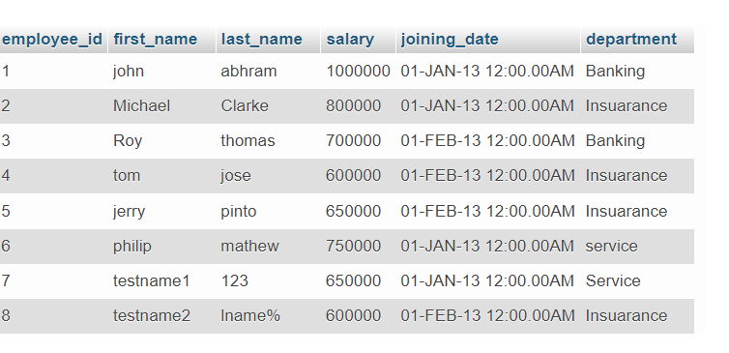

CREATE TABLE employee(employee_id int(10) NOT null PRIMARY KEY AUTO_INCREMENT,first_name varchar(25),last_name varchar(25),salary int(30),joining_date varchar(30),department varchar(30));

INSERT INTO `employee` (`employee_id`, `first_name`, `last_name`, `salary`, `joining_date`, `department`) VALUES (NULL, 'john', 'abhram', '1000000', '01-JAN-13 12:00.00AM', 'Banking'), (NULL, 'Michael', 'Clarke', '800000', '01-JAN-13 12:00.00AM', 'Insuarance');

INSERT INTO `employee` (`employee_id`, `first_name`, `last_name`, `salary`, `joining_date`, `department`) VALUES (NULL, 'Roy', 'thomas', '700000', '01-FEB-13 12:00.00AM', 'Banking'), (NULL, 'tom', 'jose', '600000', '01-FEB-13 12:00.00AM', 'Insuarance');

INSERT INTO `employee` (`employee_id`, `first_name`, `last_name`, `salary`, `joining_date`, `department`) VALUES (NULL, 'jerry', 'pinto', '650000', '01-FEB-13 12:00.00AM', 'Insuarance'), (NULL, 'philip', 'mathew', '750000', '01-JAN-13 12:00.00AM', 'service');

INSERT INTO `employee` (`employee_id`, `first_name`, `last_name`, `salary`, `joining_date`, `department`) VALUES (NULL, 'testname1', '123', '650000', '01-JAN-13 12:00.00AM', 'Service'), (NULL, 'testname2', 'lname%', '600000', '01-FEB-13 12:00.00AM', 'Insuarance');

**INCENTIVE:-**

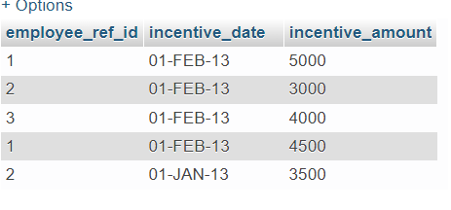

CREATE TABLE incentive(employee_ref_id int(20),incentive_date varchar(25),incentive_amount int(30));

INSERT INTO `incentive` (`employee_ref_id`, `incentive_date`, `incentive_amount`) VALUES ('1', '01-FEB-13', '5000'), ('2', '01-FEB-13', '3000');

INSERT INTO `incentive` (`employee_ref_id`, `incentive_date`, `incentive_amount`) VALUES ('3', '01-FEB-13', '4000'), ('1', '01-FEB-13', '4500');

INSERT INTO `incentive` (`employee_ref_id`, `incentive_date`, `incentive_amount`) VALUES ('2', '01-JAN-13', '3500');

**QUERIES:-**

1. **Get First_Name from employee table using Tom name “Employee Name”.**

**Ans**-SELECT *FROM employee WHERE first_name='tom';

**B)** **Get FIRST_NAME, Joining Date, and Salary from employee table.**

**Ans**-SELECT first_name,joining_date,salary FROM employee;

**C)** **Get** **all employee details from the employee table order by First_Name**

**Ascending and Salary descending?**

**Ans**-SELECT * FROM employee ORDER BY employee.first_name ASC,employee.salary DESC;

(**Note**:-SELECT * FROM employee ORDER BY employee.first_name ASC

SELECT * FROM employee ORDER BY employee.salary DESC;)

**D) d) Get employee details from employee table whose first name contains ‘J’.**

**Ans-**SELECT * FROM employee WHERE first_name LIKE '%j%';

**E)**  **Get department wise maximum salary from employee table order by salary**

**ascending?**

**Ans**-SELECT * FROM employee ORDER BY salary ASC;

**F) Select first_name, incentive amount from employee and incentives table for**

those employees who have incentives and incentive amount greater than 3000

**Ans**-SELECT first_name,incentive_amount FROM employee INNER JOIN incentive ON employee.employee_id=incentive.employee_ref_id AND incentive_amount >3000;

**TABLE 4:- SALESPERSON & CUSTOMER**

**SALESPERSON:-**

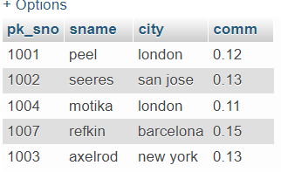

**CREATE:-**

CREATE TABLE salesperson (pk_sno int(10),sname varchar(30),city varchar(30),comm varchar(20));

**INSERT:-**

INSERT INTO salesperson (pk_sno,sname,city,comm)VALUES(1001,'peel','london',.12);

INSERT INTO salesperson (pk_sno,sname,city,comm)VALUES(1002,'seeres','san jose',.13),(1004,'motika','london',.11),(1007,'refkin','barcelona',.15),(1003,'axelrod','new york',.13);

**CUSTOMER:-**

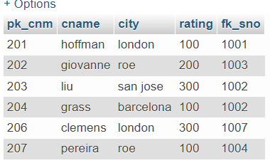

**CREATE:-**

CREATE TABLE customer (pk_cnm int(10),cname varchar(30),city varchar(30),rating int(10),pk_sno int(10),PRIMARY KEY pk_cnm,FOREIGN KEY fk_sno REFRENCES salesperson (sno));

**INSERT:-**

INSERT INTO `customer` (`pk_cnm`, `cname`, `city`, `rating`, `fk_sno`) VALUES ('201', 'hoffman', 'london', '100', '1001'), ('202', 'giovanne', 'roe', '200', '1003');

INSERT INTO `customer` (`pk_cnm`, `cname`, `city`, `rating`, `fk_sno`) VALUES ('203', 'liu', 'san jose', '300', '1002'), ('204', 'grass', 'barcelona', '100', '1002');

**QUERIES:-**

**==>Retrieve the below data from above table ?**

SELECT * FROM customer

SELECT * FROM salesperson

**a) All orders for more than $1000.**

Ans:-SELECT * FROM salesperson WHERE pk_sno >1000;

**b) Names and cities of all salespeople in London with commission above 0.12**

Ans:-SELECT sname,city,comm FROM salesperson WHERE comm >0.12 AND city = 'london';

**c) All salespeople either in Barcelona or in London**

Ans:-SELECT sname,city FROM salesperson WHERE city in ('barcelona','london');

**d) All salespeople with commission between 0.10 and 0.12. (Boundary values should be exclude)**

Ans:-SELECT sname,comm FROM salesperson WHERE comm > 0.10 AND < 0.12;

**e) All customers excluding those with rating <= 100 unless they are located in Rome**

Ans:-SELECT cname FROM customer WHERE rating <=100 OR city = 'rome';